Engineering Change Notice |  | 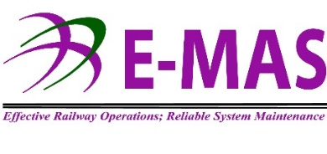
Sub-System: ____________________________
Reference No.: G00.OM_.M11161.DF.####.*
Distribution:
CEO |  | RST |  | SYS |  | OPS |  | MMT |  | HRD |  | BND
MTN |  | PNE |  | INF |  | SAS |  | PRC |  | FAD

Change Detail Descriptions
Reason for change | Remarks:
  Cost saving | New Technology | Obsolescence
  Process Improvement | Alternative | Others
Effective Date

 | Previous | New
Item Descriptions

Part No.

SAP No.

Supplier

Specification

Reference No.
(if any)
Other Information  (Mark  if updated)
  Manuals | Technical Instruction | Others
  Checklist | Maintenance Plan | _______________
Note: Kindly attach the supporting document together with this form, e.g. memo, report, picture, drawing, catalogue & etc.
 | Requested by | Checked by | Approved by | Implemented by | Verified by
Name
Signature

Department
Date
 | Originator | H.O.D | OMN | PIC | QEMR
This form was linked to Obsolescence Management Procedure [Ref. No.: G00.OMD.M12000.WO.1002.*].

