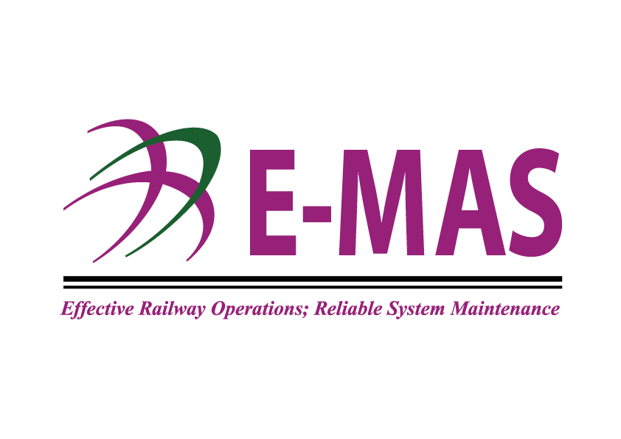

HRD Form 0020 COUNSELLING FORM
SECTION 1: EMPLOYEE DETAILS
Name of Employee |  | Employee No.
Designation |  | Department
Counselled by  [IS/HOD] |  | Session Date

SECTION 2: NATURE / DESCRIPTION OF INCIDENT
[Please state if there any previous coaching conducted and describe the incident which required counselling]
Any coaching session conducted previously? | Yes |  | If Yes, please indicate | Previous coaching session date
 |  |  |  | Previous coaching Ref. No.
Any coaching session conducted previously? | No |  | If Yes, please indicate | Note: A copy of the Coaching Form must be forwarded to HRD / CEO upon request
Please describe:

SECTION 3: COUNSELLOR’S COMMENTS
[Please attach separate documents / attachments if required]

SECTION 4 : ACTION TO BE TAKEN
[Verbal / Written Warning with Observation - 3 months / 6 months / 12 months]

SECTION 5 : EMPLOYEE’S COMMENTS
[Employee to provide comments, remarks, commitments, etc.]

SECTION 6: ACKNOWLEDGEMENT
[Note: Signatures below indicate that the counselling session has been conducted and the employee acknowledges acceptance & agreement to the above descriptions. Please attach separate documents for additional comments.]
Employee |  | Date & Time |  | Comments
Person Counselling |  | Date & Time |  | Comments
Head of Department |  | Date & Time |  | Comments
Human Resource Department |  | Date & Time |  | Comments
Chief Executive Officer |  | Date & Time |  | Comments

