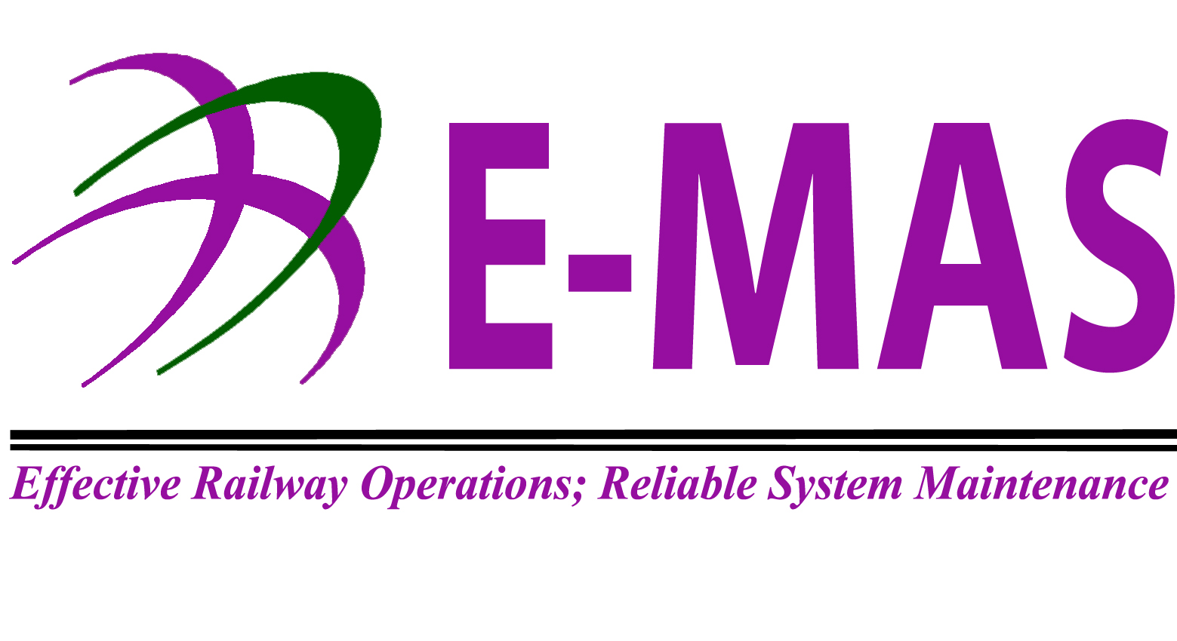
Employee Particulars
Name | : |  |  |  |  |  |  | Department |  | :
Job Designation | : |  |  |  |  |  |  | Contact No |  | :
Employee No | : |  |  |  |  |  |  | Date Joined |  | :
First Issuance Confirmation Replacement
Uniform Request |  |  |  |  | Issuance (ADM Use)
Item |  |  | Quantity | Size | Quantity | Size |  |  | Remarks |  |  | Previous balance | Latest balance
Corporate Uniform

Collared shirt short sleeve

Collared shirt long sleeve (optional for ladies)
Operations Uniform
Short Sleeve shirt
Long Sleeve shirt
Long Pants
Jacket

Maintenance Uniform
Long Pants
Collared T-Shirt
Round Neck T-shirt
Jacket
PPE
Safety Shoes (low cut)
Safety Shoes (high cut)
Safety Helmet
Safety Vest
Safety UV Sunglass
Raincoat
Safety Bump Cap
Overalls
Safety Glasses
Face Shield
Knee guard
Others (to indicate)

Staff acknowledgement and consent:
I hereby agree that in the event I lose the item/s listed in this form which I have been given and due to negligence, I will be responsible to pay the item/s. The payment will be deducted via salary deduction
Signature:  Name: | Date:
Requested By  (Applicant) | Approval By  (HOD) | Issued By  (FAD-ADM) | Received by  (Applicant)
Date | Date | Date | Date

For FAD-ADM Use
Goods Issuance No:
Initial |  | Date

